# **Computer Graphics & Multimedia [CS3CO24]**

### PRACTICAL 1

#### **AIM:**

* Introduction to Computer Graphics and it's application areas
* Elaborate various primitives used in Computer Graphics along with their advantages and disadvantages

#### **Theory:**

**Computer Graphics** is the use of computers to **create and manipulate** pictures on a display device. It comprises software techniques to **create, store, modify, and represent pictures.**

Computer Graphics is used where a set of images needs to be manipulated or the creation of the image in the form of pixels and is drawn on the computer.

The basic is the **<graphics.h>** header file in Turbo-C.

It was invented in **1960** by researchers **Verne Hudson** and **William Fetter** from **Boeing.**

Computer Graphics (an abbreviation of CG) refers to several things:

* The manipulation and the representation of the image or the data in a graphical manner.
* Various technologies are required for the creation and manipulation.
* Digital synthesis and its manipulation.

**Types of Computer Graphics**

* **Raster Graphics:** In raster, graphics pixels are used for an image to be drawn. It is also known as a bitmap image in which a sequence of images is into smaller pixels. Basically, a bitmap indicates a large number of pixels together.
* **Vector Graphics:** In vector graphics, mathematical formulae are used to draw different types of shapes, lines, objects, and so on.

**Applications**

* **Computer Graphics are used for** an **aided design for engineering and architectural systems-** These are used in electrical automobiles, electro-mechanical, mechanical, electronic devices. For example gears and bolts.
* **Computer Art –** MS Paint.
* **Presentation Graphics –** It is used to summarize financial statistical scientific or economic data. For example- Bar chart, Line chart.
* **Entertainment-** It is used in motion pictures, music videos, television gaming.
* **Education and training-** It is used to understand the operations of complex systems. It is also used for specialized systems such as framing for captains, pilots and so on.
* **Visualization-** To study trends and patterns.For example- Analyzing satellite photo of earth.

**Various primitives used in Computer Graphics**

**Input Primitives:**

The Input Devices are the hardware that is used to transfer input to the computer.

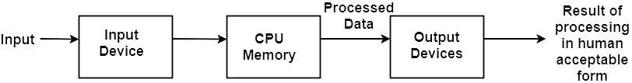

**Keyboard:**

The most commonly used input device is a keyboard. The data is entered by pressing the set of keys. All keys are labeled. A keyboard with 101 keys is called a QWERTY keyboard.

**Advantage:**

1. Suitable for entering numeric data.
2. Function keys are a fast and effective method of using commands, with fewer errors.

**Disadvantage**:

1. Keyboard is not suitable for graphics input.

**Mouse:**

A Mouse is a pointing device and used to position the pointer on the screen. It is a small palm size box. There are two or three depression switches on the top. The movement of the mouse along the x-axis helps in the horizontal movement of the cursor and the movement along the y-axis helps in the vertical movement of the cursor on the screen. 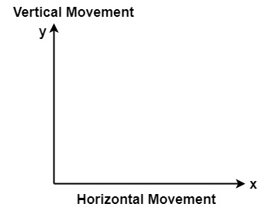

**Advantage:**

1. Easy to use
2. Not very expensive

**Trackball**

It is a pointing device. It is similar to a mouse. This is mainly used in notebook or laptop computers, instead of a mouse. This is a ball which is half inserted, and by changing fingers on the ball, the pointer can be moved.

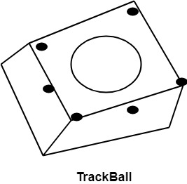

**Advantage:**

1. Trackball is stationary, so it does not require much space to use it.
2. Compact Size

**Spaceball:**

It is similar to trackball, but it can move in six directions where trackball can move in two directions only. The movement is recorded by the strain gauge. Strain gauge is applied with pressure. It can be pushed and pulled in various directions. The ball has a diameter around 7.5 cm. The ball is mounted in the base using rollers. One-third of the ball is an inside box, the rest is outside.

**Applications:**

1. It is used for three-dimensional positioning of the object.
2. It is used to select various functions in the field of virtual reality.
3. It is applicable in CAD applications.

**Joystick:**

A Joystick is also a pointing device which is used to change cursor position on a monitor screen. Joystick is a stick having a spherical ball as its both lower and upper ends as shown in fig. The lower spherical ball moves in a socket. The joystick can be changed in all four directions. The function of a joystick is similar to that of the mouse. It is mainly used in Computer Aided Designing (CAD) and playing computer games.

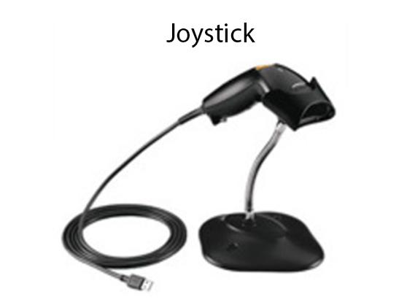

**Light Pen**

Light Pen (similar to the pen) is a pointing device which is used to select a displayed menu item or draw pictures on the monitor screen. It consists of a photocell and an optical system placed in a small tube. When its tip is moved over the monitor screen, and pen button is pressed, its photocell sensing element detects the screen location and sends the corresponding signals to the CPU.

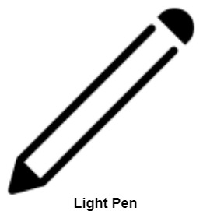

**Uses:**

1. It is used as a standard pick device with many graphics systems.
2. It can be used as stroke input devices.
3. It can be used as valuators

**Digitizers:**

The digitizer is an operator input device, which contains a large, smooth board (the appearance is similar to the mechanical drawing board) & an electronic tracking device, which can be changed over the surface to follow existing lines. The electronic tracking device contains a switch for the user to record the desired x & y coordinate positions. The coordinates can be entered into the computer memory or stored or an off-line storage medium such as magnetic tape.

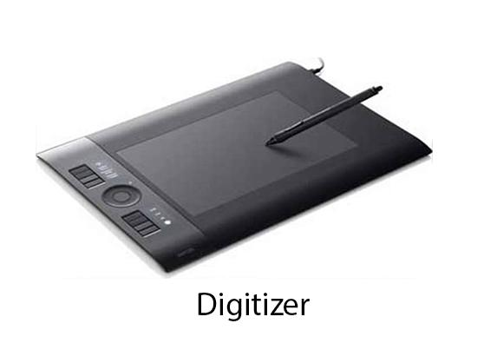

**Advantages:**

1. Drawing can easily be changed.
2. It provides the capability of interactive graphics.

**Disadvantages:**

1. Costly
2. Suitable only for applications which required high-resolution graphics.

**Touch Panels:**

Touch Panels is a type of display screen that has a touch-sensitive transparent panel covering the screen. A touch screen registers input when a finger or other object comes in contact with the screen.

When the wave signals are interrupted by some contact with the screen, that location is recorded. Touch screens have long been used in military applications.

**Voice Systems (Voice Recognition):**

Voice Recognition is one of the newest, most complex input techniques used to interact with the computer. The user inputs data by speaking into a microphone. The simplest form of voice recognition is a one-word command spoken by one person. Each command is isolated with pauses between the words.

Voice Recognition is used in some graphics workstations as input devices to accept voice commands. The voice-system input can be used to initiate graphics operations or to enter data. These systems operate by matching an input against a predefined dictionary of words and phrases.

**Advantage:**

1. More efficient device.
2. Easy to use
3. Unauthorized speakers can be identified

**Disadvantages:**

1. Very limited vocabulary
2. Voice of different operators can't be distinguished.

**Image Scanner**

The data or text is written on paper. The paper is feeded to the scanner. The paper written information is converted into electronic format; this format is stored in the computer. The input documents can contain text, handwritten material, picture extra.

By storing the document in a computer document became safe for a longer period of time. The document will be permanently stored for the future. We can change the document when we need to. The document can be printed when needed.

Types of image Scanner:

**1. Flat Bed Scanner:** It resembles a photocopy machine. It has a glass top on its top. Glass top is further covered using a lid. The document to be scanned is kept on a glass plate. The light passed underneath the side of the glass plate. The light is moved left to right. The scanning is done line by line. The process is repeated until the complete line is scanned. Within 20-25 seconds a document of 4" * 6" can be scanned.

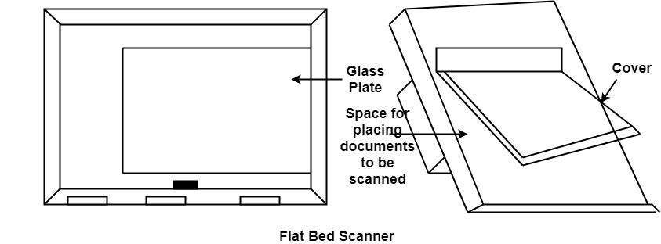

**2. Hand Held Scanner:** It has a number of LED's (Light Emitting Diodes) the LED's are arranged in the small case. It is called a Handheld Scanner because it can be kept in hand which performs scanning. For scanning the scanner is moved over the document from the top towards the bottom. Its light is on, while we move it on the document. It is dragged very slowly over the document. If dragging the scanner over the document is not proper, the conversion will not correct.

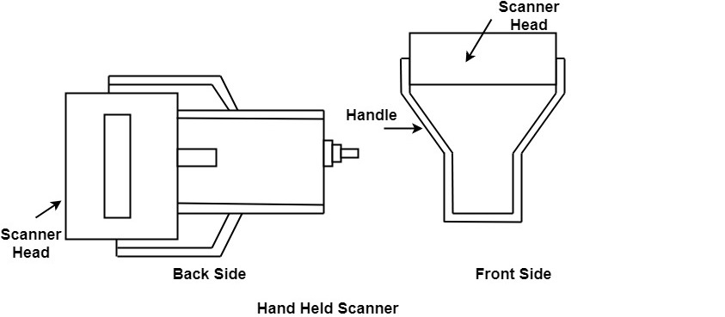

**Output Primitives:**

Output devices are used for displaying or recording the results computed by the computer. Most common output devices are the CRT display, printer, and plotter.

Following are some of the important output devices used in a computer.

* Monitors
* Graphics Plotter
* Printer

**Monitors**

Monitors, commonly called a Visual Display Unit (VDU), are the main output device of a computer. It forms images from tiny dots, called pixels that are arranged in a rectangular form. The sharpness of the image depends upon the number of pixels.

There are two kinds of viewing screens used for monitors.

* Cathode-Ray Tube (CRT)
* Flat-Panel Display

**Cathode-Ray Tube (CRT) Monitor**

The CRT display is made up of small picture elements called pixels. The smaller the pixels, the better the image clarity or resolution. It takes more than one illuminated pixel to form a whole character, such as the letter ‘e’ in the word help.

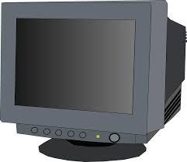

A finite number of characters can be displayed on a screen at once. The screen can be divided into a series of character boxes - fixed location on the screen where a standard character can be placed. Most screens are capable of displaying 80 characters of data horizontally and 25 lines vertically.

There are some disadvantages of CRT −

* Large in Size
* High power consumption

**Flat-Panel Display Monitor**

The flat-panel display refers to a class of video devices that have reduced volume, weight and power requirement in comparison to the CRT. Current uses of flat-panel displays include calculators, video games, monitors, laptop computer, and graphics display.

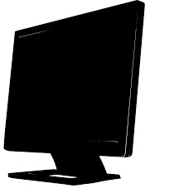

**Printers:**

Printer is the most important output device, which is used to print data on paper.

**Types of Printers:** There are many types of printers which are classified on various criteria as shown in fig:

60.7M

1.3K

Features of Java - Javatpoint

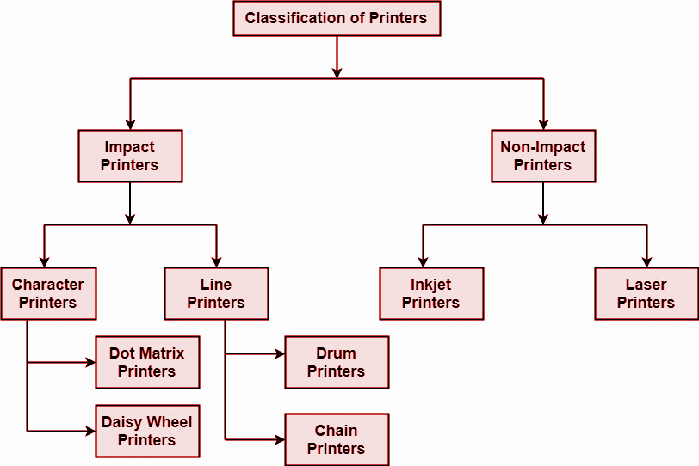

**1. Impact Printers:** The printers that print the characters by striking against the ribbon and onto the papers are known as Impact Printers.

These Printers are of two types:

1. Character Printers
2. Line Printers

**2. Non-Impact Printers:** The printers that print the characters without striking against the ribbon and onto the papers are called Non-Impact Printers. These printers print a complete page at a time, therefore, also known as Page Printers.

Page Printers are of two types:

1. Laser Printers
2. Inkjet Printers

**Dot Matrix Printers:**

Dot matrix is printed in the form of dots. A printer has a head which contains nine pins. The nine pins are arranged one below the other. Each pin can be activated independently. All or only the same needles are activated at a time. When needless is not activated, and then the tip of the needle stays in the head. When the pin works, it comes out of the print head. In nine pin printer, pins are arranged in 5 * 7 matrixes.

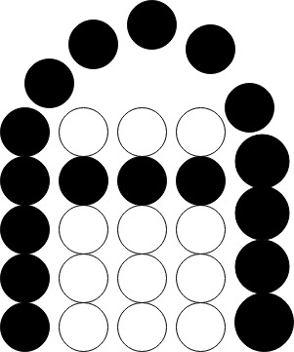 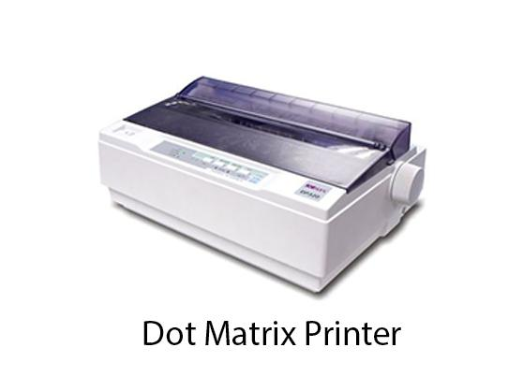

**Advantage:**

1. Dot Matrix Printers prints output as dots, so it can print any shape of the character. This allows the printer to print special character, charts, graphs, etc.
2. Dot Matrix Printers come under the category of impact printers. The printing is done when the hammer pin strikes the inked ribbon. The impressions are printed on paper. By placing multiple copies of carbon, multiple copies of output can be produced.
3. It is suitable for printing of invoices of companies.

**Daisy Wheel Printers:**

Head is lying on a wheel and Pins corresponding to characters are like petals of Daisy, that's why it's called the Daisy wheel printer.

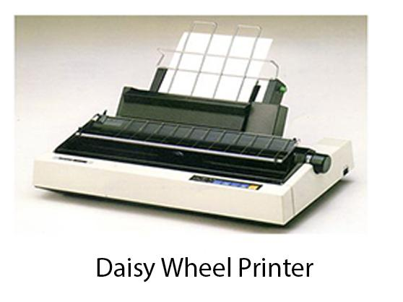

**Advantage:**

1. More reliable than DMPs
2. Better Quality

**Disadvantage:**

1. Slower than DMPs

**Drum Printers:**

These are line printers, which print one line at a time. It consists of a drum. The shape of the drum is cylindrical. The drum is solid and has characters embossed on it in the form of vertical bands. The characters are in circular form. Each band consists of some characters.

**Chain Printers:**

These are called line printers. These are used to print one line at a time. Basically, a chain consists of links. Each link contains one character. Printers can follow any character set style, i.e., 48, 64 or 96 characters. Printer consists of a number of hammers.

**Advantages:**

1. Chain or Band if damaged can be changed easily.
2. It allows printing of different forms.
3. Different Scripts can be printed using this printer.

**Disadvantages:**

1. It cannot print charts and graphs.
2. It cannot print characters of any shape.
3. Chain Printers are impact printers, hammer strikes so it is noisy.

**Non-Impact Printers:**

**Inkjet Printers:**

These printers use a special link called electrostatic ink. The printer head has a special nozzle. Nozzle drops ink on paper. Head contains up to 64 nozzles. The ink dropped is deflected by the electrostatic plate. The plate is fixed outside the nozzle. The deflected ink settles on paper.

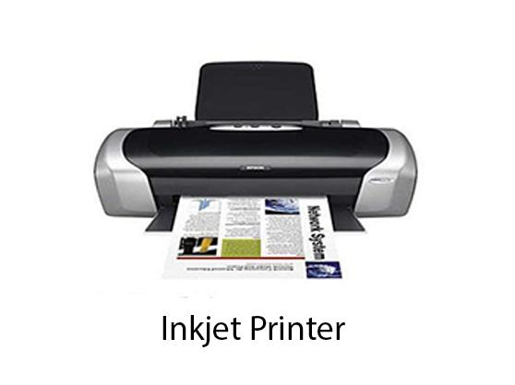

**Advantages:**

1. These produce high quality of output as compared to the dot matrix.
2. A high-quality output can be produced using 64 nozzles printed.
3. Inkjet can print characters in a variety of shapes.

**Disadvantages:**

1. Inkjet Printers are slower than dot matrix printers.
2. The cost of inkjet is more than a dot matrix printer.

**Laser Printers:**

These are non-impact page printers. They use laser lights to produce the dots needed to form the characters to be printed on a page & hence the name laser printers.

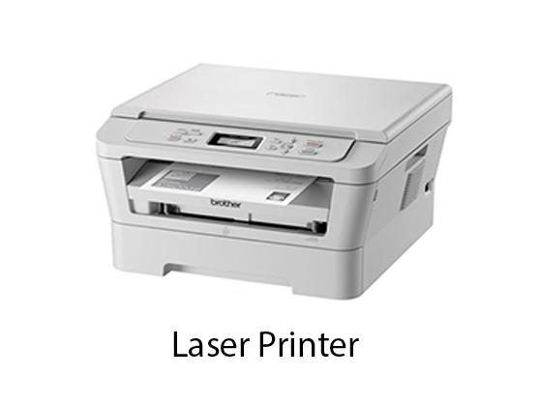

**Plotters**

Plotters are a special type of output device. It is suitable for applications:

1. Architectural plan of the building.
2. CAD applications like the design of mechanical components of aircraft.
3. Many engineering applications.

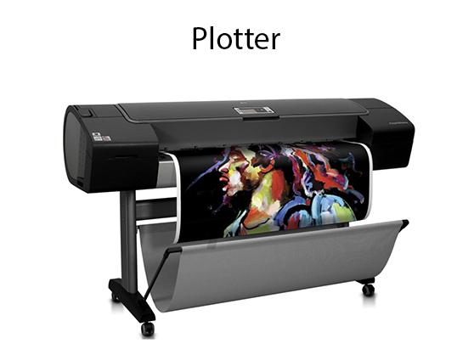

**Advantage:**

1. It can produce high-quality output on large sheets.
2. It is used to provide high precision drawing.
3. It can produce graphics of various sizes.

**Drum Plotter:**

It consists of a drum. Paper on which design is made is kept on the drum. The drum can rotate in both directions. Plotters consisted of one or more pen and penholders. The holders are mounted perpendicular to the drum surface. The pens are kept in the holder, which can move left to the right as well as right to the left. The graph plotting program controls the movement of the pen and drum.

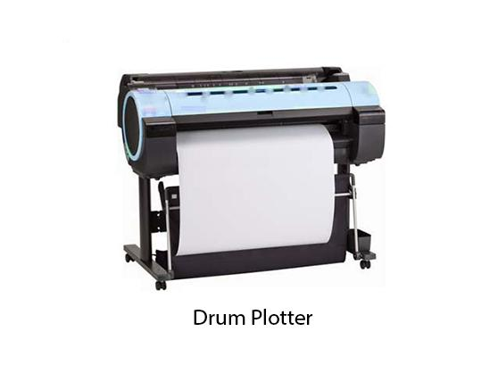

**Flatbed Plotter:**

It is used to draw complex designs and graphs, charts. The Flatbed plotter can be kept over the table. The plotter consists of a pen and a holder. The pen can draw characters of various sizes. There can be one or more pens and pen holding mechanisms. Each pen has ink of different colors. Different colors help to produce multicolor design of documents. The area of plotting is also variable. It can vary A4 to 21'*52'.

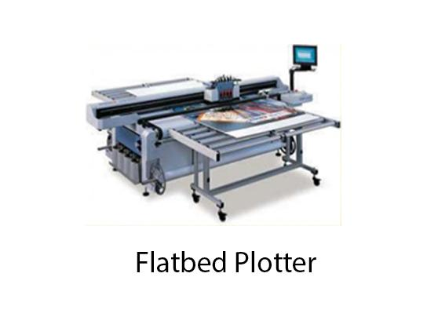

It is used to draw

1. Cars
2. Ships
3. Airplanes
4. Shoe and dress designing
5. Road and highway design